Personal project

# Questions to answer for the personal challenge

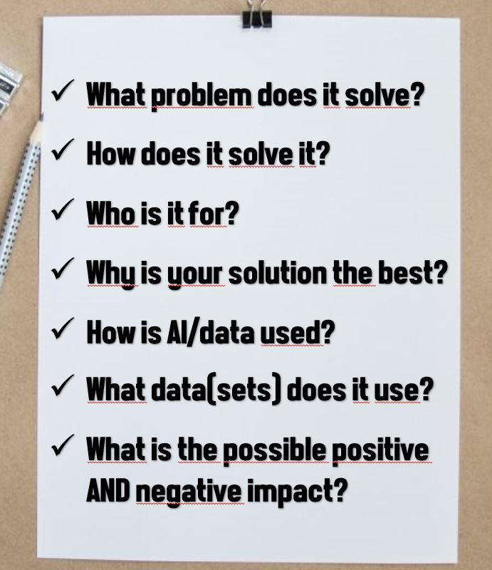

# Description of the projects

What I would like to build with AI that would benefit society. I want to make an application that I would find use in.

* Recipes personalized to what people ate and what they would like as well.

## PDR

1 - Societal Impact - The student is able to approach the context and impact of their own AI project(s) from different perspectives in a sustainable way. In addition, the student is able to reflect on their own choices, taking into account data legislation and the (possible) impact on society.

2 - Investigative Problem Solving - The student is able to critically look at their own AI project(s) from different perspectives, recognize problems and come up with appropriate solutions.

3 - Data Preparation - The student is able to collect data and estimate its quality and usability. The student is also able to adjust the data if necessary for proper usage in their project(s).

4 - Machine Teaching - The student is able to use data to train models in a way that fits the intended purpose. The student is also able to test whether the models have been adequately trained

5 - Data Visualisation - The student is able to use data to create an interesting, informative and

compelling story in an (interactive) data visualization product, tailored to the right target group.

6 – Reporting - The student is able to report in a methodologically sound manner on (the outcome of) own AI projects (project proposal, process documentation, reporting of final results, etc.).

7 - Personal Leadership - The student shows an entrepreneurial mindset regarding their own AI project(s) and personal development, while being aware of their own learning capacity and keeping in mind professional ambitions in their future work field.

8 - Personal Goal - <With this learning outcome, the student can set its own goal in relation to their future field of work. Describe this Learning Outcome in your PDR.>

|  |  |  |  |  |  |
| --- | --- | --- | --- | --- | --- |
|  | Advanced | Proficient | Beginning | Orienting | Undefined |
| 1 |  |  |  |  |  |
| 2 |  |  |  |  |  |
| 3 |  |  |  |  |  |
| 4 |  |  |  |  |  |
| 5 |  |  |  |  |  |
| 6 |  |  |  |  |  |
| 7 |  |  |  |  |  |
| 8 |  |  |  |  |  |

* Recipes personalized to what people ate and what they would like as well.

The app would allow the users to personalize a profile of multiple dishes that they have already tried. Making suggestions of similar dishes that the user could make taking in consideration the ingredients that he would use most frequently.

Maybe suggest to the user if they would like to make it or made it before to get more personalized prefferences.

Data set : <https://www.kaggle.com/datasets/kaggle/recipe-ingredients-dataset>

# Questions on project

* People are introduced to alternative food that could be made with similar products
* It recommends the user recipes that they made before comparing the products that they used before.
* It is targeting people to who are used to making same meals but want that variation.
* Because it will personalize users habbits of what they made before or made quite frequently. Recommending new recipes that would be similar to the items they used.
* Ai will try to acquire ingredients within the other recepies based on users profile.
* Recipe data set from keggle of recipes.
* Good / Encourages people to vary their usual meals and encourage improving their cooking skills |

Bad / IDK